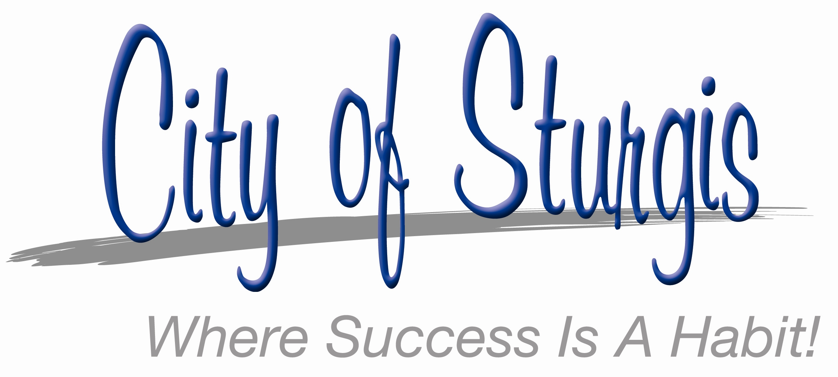
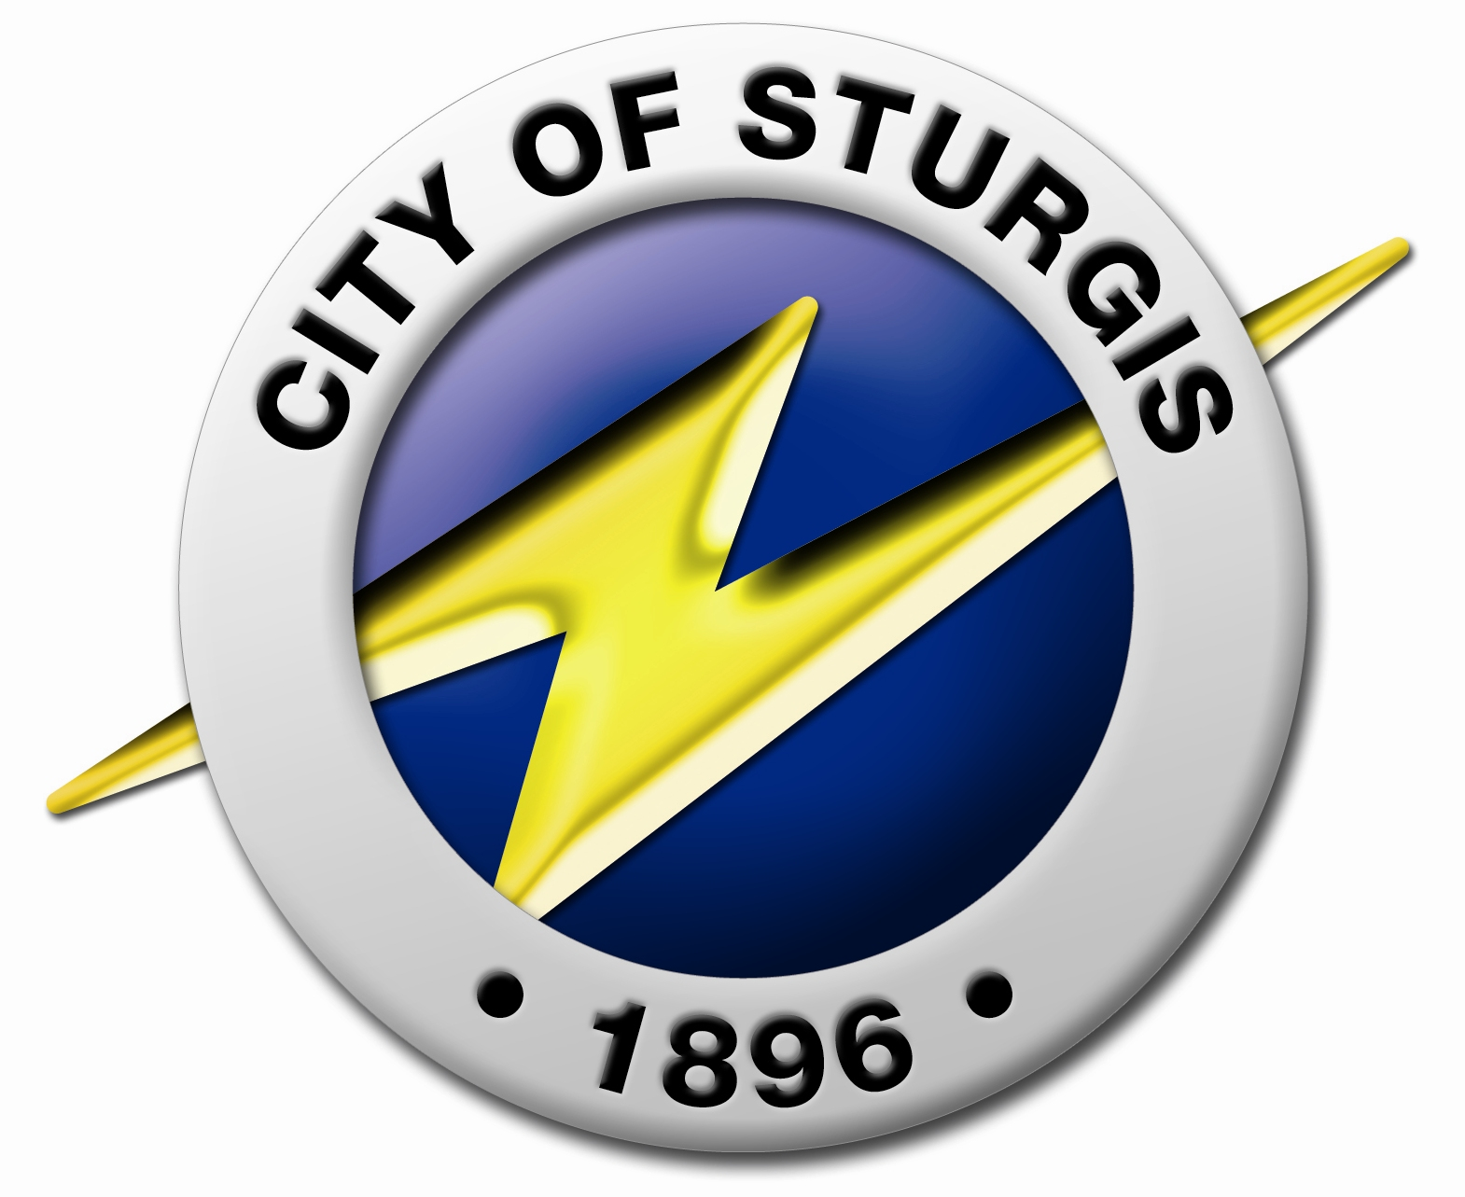
130 N. Nottawa
Sturgis, MI 49091
(269) 651-2321

Contact: Andrew Kuk
E-mail: akuk@sturgismi.gov
Office Phone: (269) 651-7324
2/26/2014
FOR IMMEDIATE RELEASE

Multiple Sturgis Street Projects Scheduled for 2014
STURGIS – At Wednesday’s Sturgis City Commission meeting, approval was given for design work on several street improvement projects. This is another step completed in what will be a busy year for street improvements in Sturgis. In addition to ongoing routine maintenance necessary after the long, unseasonably harsh winter, the City will be completing several major street projects during 2014. In August the City plans to wrap up street work with a crack sealing program.
S. Nottawa Street
The first of the major reconstruction projects is S. Nottawa Street. With the assistance of a grant from the State of Michigan, the City will be reconstructing the street from the US-12 intersection to the Congress Street intersection, replacing the road with a new brick street. This project is scheduled to begin in late April and run until late July.
Progress and Broadus Streets
Due to business expansion by Midwest Plastic Engineering, Inc. and Summit Polymers, the City was able to apply for and receive grant funding to complete street repairs on streets in the Sturgis Airport Industrial Park. Repair work will take place on Progress Street from Broadus to the City limits, and Broadus Street from Progress to W. Dresser Drive. This project is also expected to begin either in late April or May.
N. Franks
In June or July, crews are expected to start road work on North Franks from E. Chicago Road to the Doyle Center. This project is being supported with funding from the Michigan Department of Environmental Quality’s Scrap Tire grant.
N. Centerville Road
From June thru August, work is scheduled to take place on N. Centerville Road from US-12 to the railroad tracks. Along with street improvements, traffic signal improvements including pedestrian signals and widening for a full turn lane will occur at the W. West Street intersection. Michigan Southern Railroad is also expected to repair the railroad crossing on N. Centerville Road during the construction project.
Mill and Resurfacing Projects
Several City streets are planned for extensive rehabilitation in 2014. In late April work will be done on parts of W. Lafayette and Park Street. Starting sometime in July additional streets designated for improvements will include: S. Lakeview from Mechanic to south of Merribe Street; E. Hatch from N. Lakeview to N. Franks; and S. Clay from US-12 to W. South. W. Congress from S. Clay to S. Nottawa will also be worked on, a short-term fix until a full reconstruction of W. Congress can take place.
All timeframes listed depend on several factors including contractor schedules, weather, and other unforeseen events, but do represent the best current estimate of when work will begin.
###

